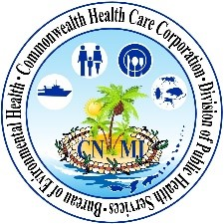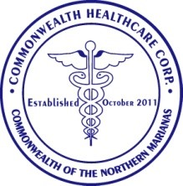

**5 Steps to Obtaining a Food Handler’s Certificate**

For more information, please visit our website at [www.chcc.gov.mp](http://www.chcc.gov.mp) or call the BEH office at (670) 664-4870/2/3.

**NOTE:**

**FH’s under treatment or who have not successfully passed a health exam must go to the BEH office once they have been cleared by a licensed physician to receive their FH Certificate.**

**FH must be employed by a permitted food & drink establishment.**